SCHOOL OF COMPUTER SCIENCE AND ARTIFICIAL INTELLIGENCE |  |  |  |  | DEPARTMENT OF COMPUTER SCIENCE ENGINEERING
Program Name: M.Tech. and MCA |  |  |  | Assignment Type: Lab |  |  | AcademicYear:2025-2026
Course Coordinator Name |  |  |  | Venkataramana Veeramsetty
Course Code |  |  |  | Course Title |  | AI Assisted Problem Solving Using Python
Year/Sem |  |  | I/I | Regulation |  | R24
Date and Day  of Assignment |  |  | Week3 - Monday | Time(s)
Duration |  |  | 2 Hours | Applicable to  Batches |  | M.Tech. and MCA
AssignmentNumber:4.3(Present assignment number)/24(Total number of assignments)
 | Q.No. | Question |  |  |  |  |  | Expected Time  to complete
 | 1 | Lab 4: Advanced Prompt Engineering – Zero-shot, One-shot, and Few-shot Techniques  Lab Objectives:  - To explore and apply different levels of prompt examples in AI-assisted code generation.  - To understand how zero-shot, one-shot, and few-shot prompting affect AI output quality.  - To evaluate the impact of context richness and example quantity on AI performance.  - To build awareness of prompt strategy effectiveness for different problem types.  Lab Outcomes (LOs):  After completing this lab, students will be able to:  - Use zero-shot prompting to instruct AI with minimal context.  - Use one-shot prompting with a single example to guide AI code generation.  - Apply few-shot prompting using multiple examples to improve AI responses.  - Compare AI outputs across the three prompting strategies.  Task Description#1  - CZero-shot: Prompt AI to write a function that checks whether a given year is a leap year.  Expected Output#1  - AI – generated function with no examples provided  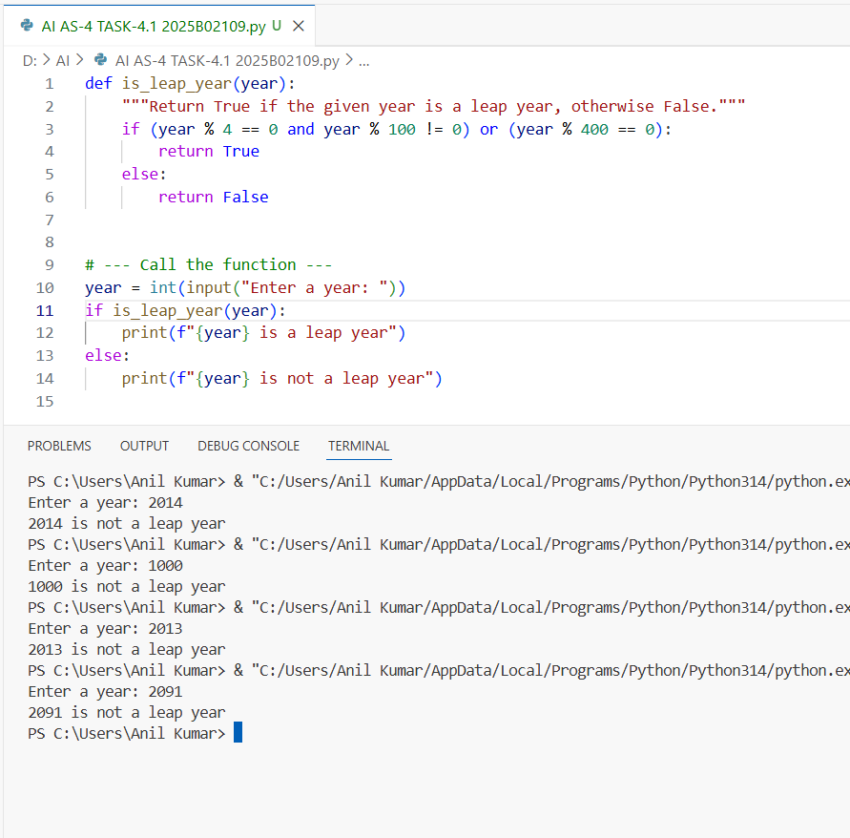  Task Description#2  - One-shot: Give one input-output example to guide AI in writing a function that converts centimeters to inches.  Code:  Expected output#2  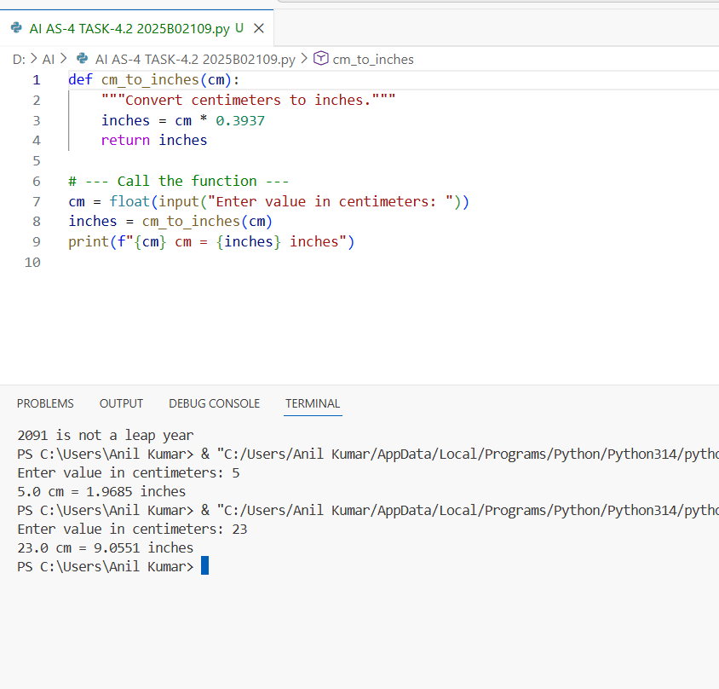  Task Description#3  - Few short :provided 2-3 examples to generate a function that formates full names as “Last, Fast”  Expected Output#3  - Well-structured function respecting the examples  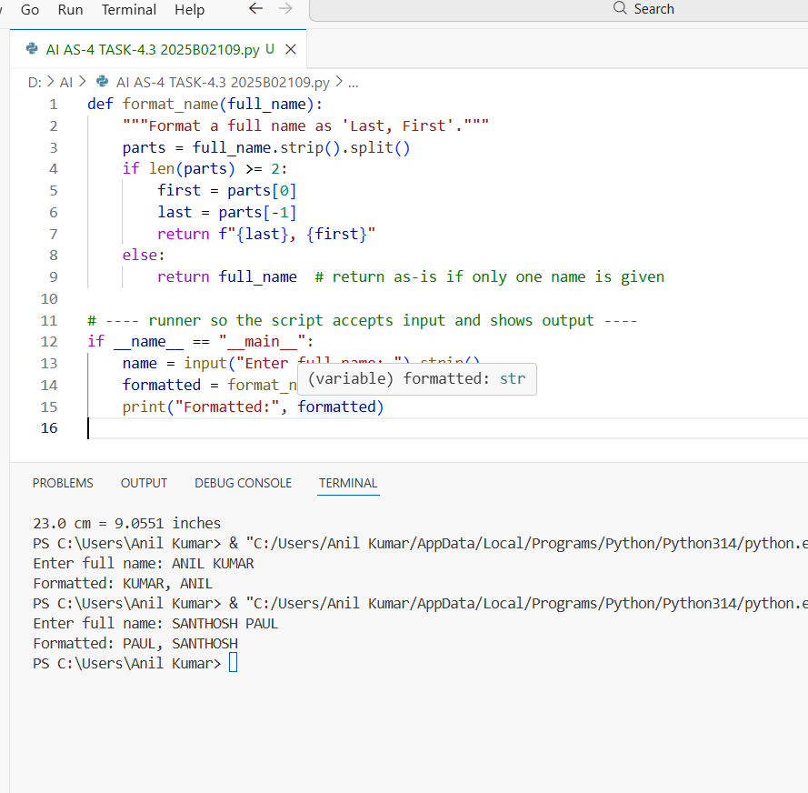  Task Description#4  - Compare zero-shot and few-shot prompts for writing a function that counts the number of vowels in a string.  Expected Output#4  - Functional output and comparative reflection.  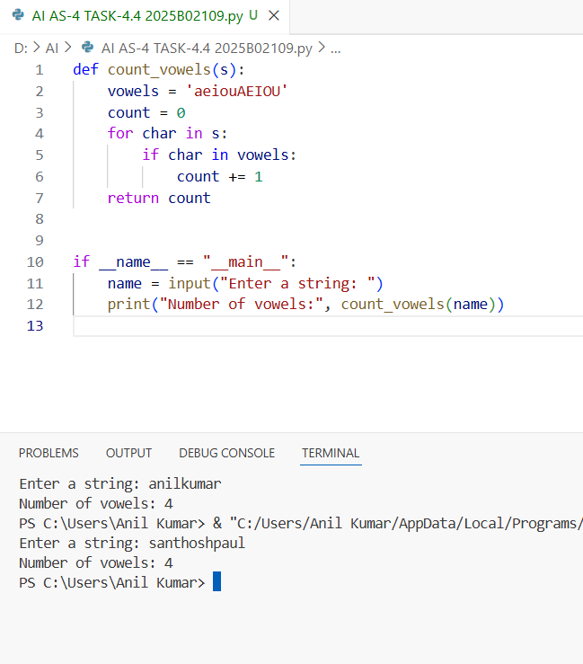  Comparative Reflection  Task Description#5  ●Use few-shot prompting to generate a function that reads a .txt file and returns the Comparative Reflection  number of line  Aspect Zero-shot Prompt Few-shot Prompt  Input Style Simple instruction only Instruction + examples  Function Output Works correctly, but style varies Works correctly and follows example style  Naming Convention Random (count_vowels) Consistent with examples (vowel_counter)  Logic Explicit loop with counter Uses concise list comprehension  Control over Output Limited High (can guide style, naming, structure)  Error Likelihood Slightly higher for complex tasks Reduced (model imitates examples)  Best Use Case Quick general solutions Consistent code generation across tasks  .  Expected Output#5  - Working file-processing function with AI-guided logic  OUTPUT:  # Example 1: Function to count words in a .txt file  def count_words_in_file(filename):  with open(filename, 'r') as file:  text = file.read()  words = text.split()  return len(words)  # Example 2: Function to count characters in a .txt file  def count_characters_in_file(filename):  with open(filename, 'r') as file:  text = file.read()  return len(text)  # AI-guided logic:  # Observing both examples, each reads the file, processes the content differently,  # and returns a count. So, to count lines, we can follow the same structure but use readlines().  def count_lines_in_file(filename):  """Reads a .txt file and returns the number of lines."""  try:  with open(filename, 'r') as file:  lines = file.readlines()  return len(lines)  except FileNotFoundError:  return "Error: File not found."  except Exception as e:  return f"An error occurred: {e}"  # Example usage:  # print(count_lines_in_file("sample.txt"))  AI-Guided Logic Steps  - Pattern Recognition:  The AI recognized a pattern from examples — open file → process → return count.  - Task Adaptation:  Instead of counting words or characters, the AI applies the logic to lines using readlines().  - Error Handling:  Added try-except blocks for real-world reliability (e.g., missing files  Note: Report should be submitted a word document for all tasks in a single document with prompts, comments & code explanation, and output and if required, screenshots  Evaluation Criteria:  Criteria Max Marks  Zero Shot (Task #1) 2.5  One Shot (Task#2) 2.5  Few Shot (Task#3 & Task #5) 2.5  Comparison (Task#4) 2.5  Total 10 Marks |  |  |  |  |  | Week3 - Monday

